*Highlighted part is either note to internal team or content that needs to be replaced with correct values e.g. email addresses, dates, etc.*

Below is a complete Child Data Protection Policy draft for SproutSong / SproutMentors, prepared for internal team review, DPDP compliance tracking, and later website publication.

This policy is important because your internal DPDP/security documents classify student data as high-risk, especially where the platform handles student identity, DOB, class, parent details, academic performance, attendance, counselling data, documents, AI reports, and login/security data.

---

SproutSong / SproutMentors

Child Data Protection Policy

Internal Review Draft for Compliance Tracking

Document Name: Child Data Protection Policy
Platform: SproutSong / SproutMentors
Version: v1.0 Draft
Prepared For: Internal Team Review, DPDP Compliance Tracking, Website Publication
Status: Draft — Not Yet Published
Effective Date: To be added after approval
Last Updated: To be added after approval
Contact Email: privacy@sproutsong.com / support@sproutsong.com

---

Internal Review Checklist

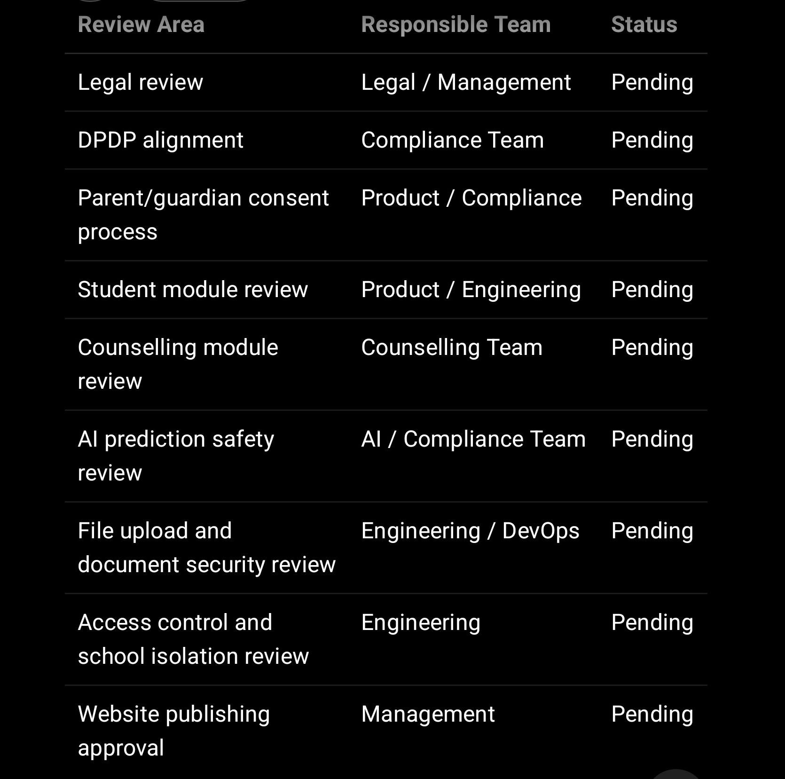

---

1. Purpose of This Policy

SproutSong / SproutMentors works with students, parents, teachers, schools, counsellors, mentors, and educational institutions. Because many students using the platform may be under 18 years of age, their data requires special care.

This Child Data Protection Policy explains:

What children’s data we collect
Why we collect it
How we use it
Who can access it
How parent/guardian consent is handled
How children’s data is protected
How AI-assisted analysis is controlled
How uploaded student documents are secured
How parents/guardians can request access, correction, withdrawal, or deletion
How long children’s data is retained

The core principle is:

Protect the student first. Collect only what is necessary. Give access only to the right person. Store proof of consent. Log every sensitive action. Avoid harmful profiling.

This aligns with your internal security guidance, which states that the team should ask whether data is necessary, whether child data is involved, whether parent/guardian consent is required, whether access is protected, whether school-level isolation is checked, whether files are private, and whether deletion/retention exists.

---

2. Scope of This Policy

This policy applies to all SproutSong / SproutMentors systems, websites, portals, dashboards, forms, APIs, databases, mobile/web applications, file storage, reports, AI-assisted tools, counselling tools, and internal admin panels that process children’s data.

It applies to:

Students
Parents / guardians
Schools and institutions
Teachers
Mentors
Counsellors
School admins
Principals
SproutSong support/admin users
Technical/development teams
Third-party processors where applicable

It covers the following modules:

Students
Classes
Attendance
Homework
Assignments
Tasks / Projects
Exams
Assessments
Reports
Counselling
Career guidance
AI-assisted reports
Student documents
Activities / Events
Parent portal
Teacher portal
Principal dashboard
School admin dashboard

---

3. Definition of Children’s Data

For this policy, children’s data means any personal data related to a student who is below the legally applicable age of adulthood.

Children’s data may include:

Student name
Date of birth
Gender
Class, section, roll number, admission number
School name
Parent/guardian name, phone, email
Academic marks, grades, reports, assessments
Attendance and absence records
Homework, assignments, project submissions
Counselling information
Career interests and preferences
Behavioural or participation records
Student photo or profile image
Uploaded marksheets, certificates, reports, documents
AI-assisted insights or recommendations
Login/security data such as user ID, password hash, OTP records, session records
Platform usage data

Your uploaded DPDP/security report specifically identified student personal data, parent data, academic performance, attendance reasons, login data, AI training/report data, and counselling/report data as high-risk areas.

---

4. What Children’s Data We Collect

SproutSong / SproutMentors may collect children’s data depending on the feature or service being used.

4.1 Student Identity Data

Examples:

Student full name
Class and section
Roll number
Admission number
School/institution
Gender
Date of birth
Date of joining
Student profile photo

Purpose:

Account creation
Student identification
Class allocation
School administration
Report generation
Parent/school communication

---

4.2 Parent / Guardian Data

Examples:

Parent/guardian name
Relationship with student
Phone number
Email address
Consent details
Communication preferences

Purpose:

Parent account creation
Student data consent
Academic communication
Attendance alerts
Reports and counselling updates
Security and verification

---

4.3 Academic Data

Examples:

Marks
Grades
Subjects
Assignments
Homework
Projects
Exam records
Assessment records
Reports
Learning progress
Syllabus progress where linked to student performance

Purpose:

Teaching and learning support
Academic tracking
Evaluation
Report generation
Teacher/student/parent communication
School performance monitoring

---

4.4 Attendance and Participation Data

Examples:

Attendance status
Date of attendance
Leave status
Limited absence reason category
Activities and event participation
Sports or extracurricular participation

Purpose:

School attendance management
Student safety
Academic participation tracking
Parent updates
School administration

Important rule:

Absence reasons should be limited to necessary information only. Free-text reasons should not include unnecessary medical, family, or sensitive personal details. Your DPDP/security report recommends controlled absence categories and restricted visibility for reason notes.

---

4.5 Counselling and Career Guidance Data

Examples:

Career interests
Subject preferences
Academic history
Counselling notes
Parent/student inputs
Education goals
Preferred stream/course/career
Uploaded marksheets or reports
Counsellor observations

Purpose:

Educational guidance
Career counselling
Stream/course guidance
Parent-ready reports
Student support planning

Counselling data is considered high-risk because it may include personal interests, academic challenges, emotional observations, financial context, or sensitive family information.

---

4.6 Student Documents

Examples:

Marksheets
Certificates
Student photographs
Academic reports
Counselling documents
Assessment reports
School certificates or forms

Purpose:

Verification
Counselling assessment
Academic reporting
Student profile management
School operations

Uploaded documents should be stored in private storage only. Your file upload guide requires private bucket storage for sensitive student/school documents, signed URL access, UUID naming, file size/type validation, and access control before download.

---

4.7 AI-Assisted Data

Examples:

Academic summaries
Learning recommendations
Career suggestions
Counselling report drafts
Parent-ready summaries
Principal dashboard insights
AI processing logs

Purpose:

Educational guidance
Learning support
Academic analysis
Teacher/counsellor assistance
Parent communication
School improvement insights

AI must be assistive, reviewed, explainable, and should not harmfully label children. Your internal guide states that AI outputs should minimise data, remove identifiers where possible, avoid storing sensitive prompts, require consent, require human review for counselling/career guidance, and avoid harmful labels such as “weak”, “failure risk”, and “low potential”.

---

5. Why We Collect Children’s Data

SproutSong / SproutMentors collects children’s data only for valid educational, academic, administrative, safety, counselling, communication, reporting, and student support purposes.

We may use children’s data for:

Student registration and account creation
Class allocation
Attendance tracking
Homework and assignment management
Exam and assessment management
Academic report generation
Counselling and career guidance
Learning recommendations
Parent-teacher communication
School administration
Student support and intervention planning
AI-assisted educational analysis
Platform safety and security
Legal/compliance record keeping

We do not collect children’s data for unnecessary purposes.

We do not use children’s data for targeted advertising.

We do not sell children’s data.

We do not use children’s data to create harmful labels or negative profiling.

---

6. Parent / Guardian Consent

For students under 18, SproutSong / SproutMentors requires parent, lawful guardian, or school-authorised consent before collecting or processing children’s personal data where required.

Your internal DPDP guide states that processing children’s data requires verifiable parent/lawful guardian consent, and for sensitive workflows a simple checkbox is not sufficient; the parent must actively confirm their identity as guardian.

6.1 When Consent Is Required

Consent is required for:

Student registration
Parent account linking
Counselling forms
Career guidance forms
Marksheet/document upload
AI-assisted report generation
Academic reports
Attendance processing
Email/SMS/WhatsApp communication
Photo/media usage
Analytics/tracking where applicable

6.2 How Consent Is Captured

Consent may be captured through:

Checkbox confirmation
Parent/guardian declaration
OTP verification
Email verification
School-authorised declaration
Signed school agreement
Admin-recorded consent entry

For sensitive student workflows such as counselling, marksheet upload, AI-assisted analysis, and parent-student linking, consent should include:

Parent/guardian name
Relationship to student
Mobile/email used for verification
Consent timestamp
IP address
User agent
Consent version
Privacy Policy version
Terms version
Consent text agreed by the user
Checkbox checked status
Request ID / audit log ID

6.3 Sample Consent Text

I confirm that I am the parent or lawful guardian of the student named in this form.

I consent to SproutSong / SproutMentors collecting, storing, and processing the student’s personal, academic, attendance, counselling, document, and learning-related data for educational, academic, counselling, reporting, communication, and student support purposes.

I understand that the data will be accessed only by authorised school users, assigned teachers, authorised counsellors/mentors, parents/guardians, and platform administrators where required.

I understand that I may request access, correction, withdrawal of consent, or deletion by contacting privacy@sproutsong.com.

Checkbox:

☐ I confirm that I am the parent/lawful guardian and consent to processing the student’s data.

---

7. School-Authorised Student Data Processing

In many cases, schools may create student records or upload academic data on behalf of students and parents.

Where a school or institution submits student data, the school confirms that:

It is authorised to submit the student data.
It has obtained required parent/guardian consent where applicable.
It will assign correct roles and access permissions.
It will not upload unnecessary student data.
It will ensure staff use the platform responsibly.

Sample school-authorised declaration:

I confirm that I am authorised by the school/institution to create or update this student record on SproutSong / SproutMentors.

I confirm that the school has obtained the required parent/guardian consent where applicable and that the student data is being submitted only for educational, academic, administrative, communication, reporting, counselling, and student support purposes.

---

8. How Children’s Data Is Used

Children’s data may be used only for the purposes described in this policy and the applicable Privacy Policy.

8.1 Allowed Use

Allowed use includes:

Academic management
Attendance tracking
Class and timetable management
Homework and assignments
Exam and assessment management
Parent communication
Counselling and guidance
AI-assisted educational support
Student progress reports
Teacher/student support planning
School-level aggregated analytics

8.2 Not Allowed

Children’s data must not be used for:

Targeted advertising to children
Selling data to third parties
Negative profiling
Unfair ranking or harmful labelling
Unauthorised sharing with other students/parents
Public disclosure without consent
Using student documents for unrelated purposes
Training third-party AI models without specific consent
Disciplinary decisions based only on AI output
Psychological or medical diagnosis by AI

Your form security guide specifically says children’s data should not be used for advertising profiling, and student interests, preferred college, or budget should be used only for counselling purposes.

---

9. AI and Student Prediction Safety

SproutSong / SproutMentors may use AI-assisted tools for:

Career guidance
Academic performance analysis
Counselling reports
Learning recommendations
Parent-ready summaries
Principal dashboard insights

AI must follow these rules:

AI output must be reviewed before final use.
AI output must be explainable and understandable.
AI should minimise student data.
Personal identifiers should be removed where possible.
Sensitive prompts should not be stored unnecessarily.
AI should not create harmful labels.
AI should not make final decisions about a child.
AI should not be used for targeted advertising or harmful profiling.
AI-assisted counselling/career guidance must include human review.

Avoid:

This student is weak.
This student is not suitable for Science.
This child has poor intelligence.
High failure risk.
Low potential.

Use:

The student may need additional support in...
Current indicators suggest exploring...
Recommended areas for improvement...
The student shows stronger alignment with...
This recommendation should be reviewed by a counsellor/parent.

Your internal guide uses this exact structure for AI safety and student prediction safety.

---

10. Who Can Access Children’s Data

Access to children’s data must follow role-based access control and school-level isolation.

10.1 Student

Students may access:

Their own profile
Their own timetable
Their own attendance
Their own homework/assignments
Their own approved reports
Their own approved AI/counselling summaries

Students must not access another student’s data.

10.2 Parent / Guardian

Parents/guardians may access:

Their own child’s profile
Their own child’s reports
Their own child’s attendance
Their own child’s homework/assignments
Their own child’s approved counselling/AI reports
Fee/payment details if applicable and authorised

Parents must not access another child’s data.

10.3 Teacher / Coordinator

Teachers/coordinators may access:

Assigned class data
Assigned students
Subject-specific academic data
Attendance marking
Lesson plans
Homework and assignments for assigned students

Teachers must not access unrelated students, other school data, financial data, or unnecessary counselling notes.

10.4 Counsellor / Mentor

Counsellors/mentors may access:

Assigned counselling cases
Relevant student academic/counselling inputs
Approved documents needed for counselling
AI-assisted counselling drafts requiring review

They must not access non-assigned students or other schools’ data.

10.5 Principal / School Admin

Principal/school admin may access:

School-level student data
School dashboard
Assigned users
Operational records
School-scoped analytics

They must not access other schools’ data.

10.6 Super Admin / Technical Support

Super admin/technical support access must be limited to what is necessary for operations, support, security, and compliance.

Raw passwords, private notes, and unnecessary sensitive PII should not be exposed even to super admin by default. Your access-control policy states that raw passwords, private notes, and sensitive PII should never be exposed even to super admin, and that backend permission checks must independently enforce access.

---

11. How Children’s Data Is Protected

SproutSong / SproutMentors should use technical, organisational, and administrative safeguards.

11.1 Authentication

Strong password hashing using bcrypt or Argon2
No plain-text passwords
OTP verification where needed
Secure session management
HttpOnly secure cookies
MFA for admin/principal/super admin
Token invalidation on role/password changes

Your DPDP/security report identified plain password storage in student/teacher data as a critical risk and recommended removing plain passwords, using bcrypt/Argon2, and moving authentication to a separate users/auth collection.

---

11.2 Authorisation

Role-based access control
School-level isolation
Object-level ownership checks
Parent-child relationship checks
Teacher-class assignment checks
Counsellor-case assignment checks
Separate access for sensitive data

Required rule:

A user can access children’s data only if:
1. the user is authenticated,
2. the user belongs to the same school,
3. the user has permission for the module,
4. the user is linked to the student/class/case,
5. the action is allowed for the user’s role.

---

11.3 Database Protection

MongoDB authentication
Private network binding
No public MongoDB port
Least-privilege DB users
Field-level encryption for sensitive data
Encrypted backups
Production data masking in development
No root DB credentials in app code

Your DPDP/security report recommends MongoDB authentication, private network binding, TLS/SSL, field-level encryption, no public MongoDB port, encrypted backups, and not using production data in development without masking.

---

11.4 File Protection

Student files and documents must be protected using:

Private storage buckets
No direct public file URLs
Server-generated signed URLs
Short expiry for downloads
File type validation
MIME validation
File size limits
No executable/script uploads
UUID file names
Access control before download
Malware scanning where possible

Your file upload guide requires private storage for sensitive files, signed URL access, UUID naming, no executable uploads, access control before download, server-side validation, and no direct public folder storage.

---

11.5 Secure Logging

Logs must not contain:

Student full name
Parent phone/email
Passwords
OTP
JWT tokens
Aadhaar/PAN/government IDs
Counselling notes
Full request/response bodies
Student documents
Sensitive AI prompts
Bank/payment details

Your secure logging guide warns that PII in logs, tokens in logs, passwords in logs, stack traces, Aadhaar in logs, and cross-school data in logs can become breach vectors.

---

12. Data Sharing and Third Parties

SproutSong / SproutMentors may use third-party processors for:

Cloud hosting
Email services
SMS/OTP services
Payment gateways, if used
Analytics providers, if used
File storage providers
AI API providers, if used
Monitoring and security tools

Children’s data should be shared with third parties only where necessary for platform services, subject to appropriate security and contractual controls.

Student data should not be sold.

Student data should not be used for third-party advertising.

Student data should not be shared with colleges, advertisers, or external partners without clear purpose and separate consent where required.

Your internal guide specifically asks the team to list third-party tools and identify which third-party services receive SproutSong data.

---

13. Data Retention

Children’s data should be retained only as long as necessary for the stated purpose.

Suggested retention periods:

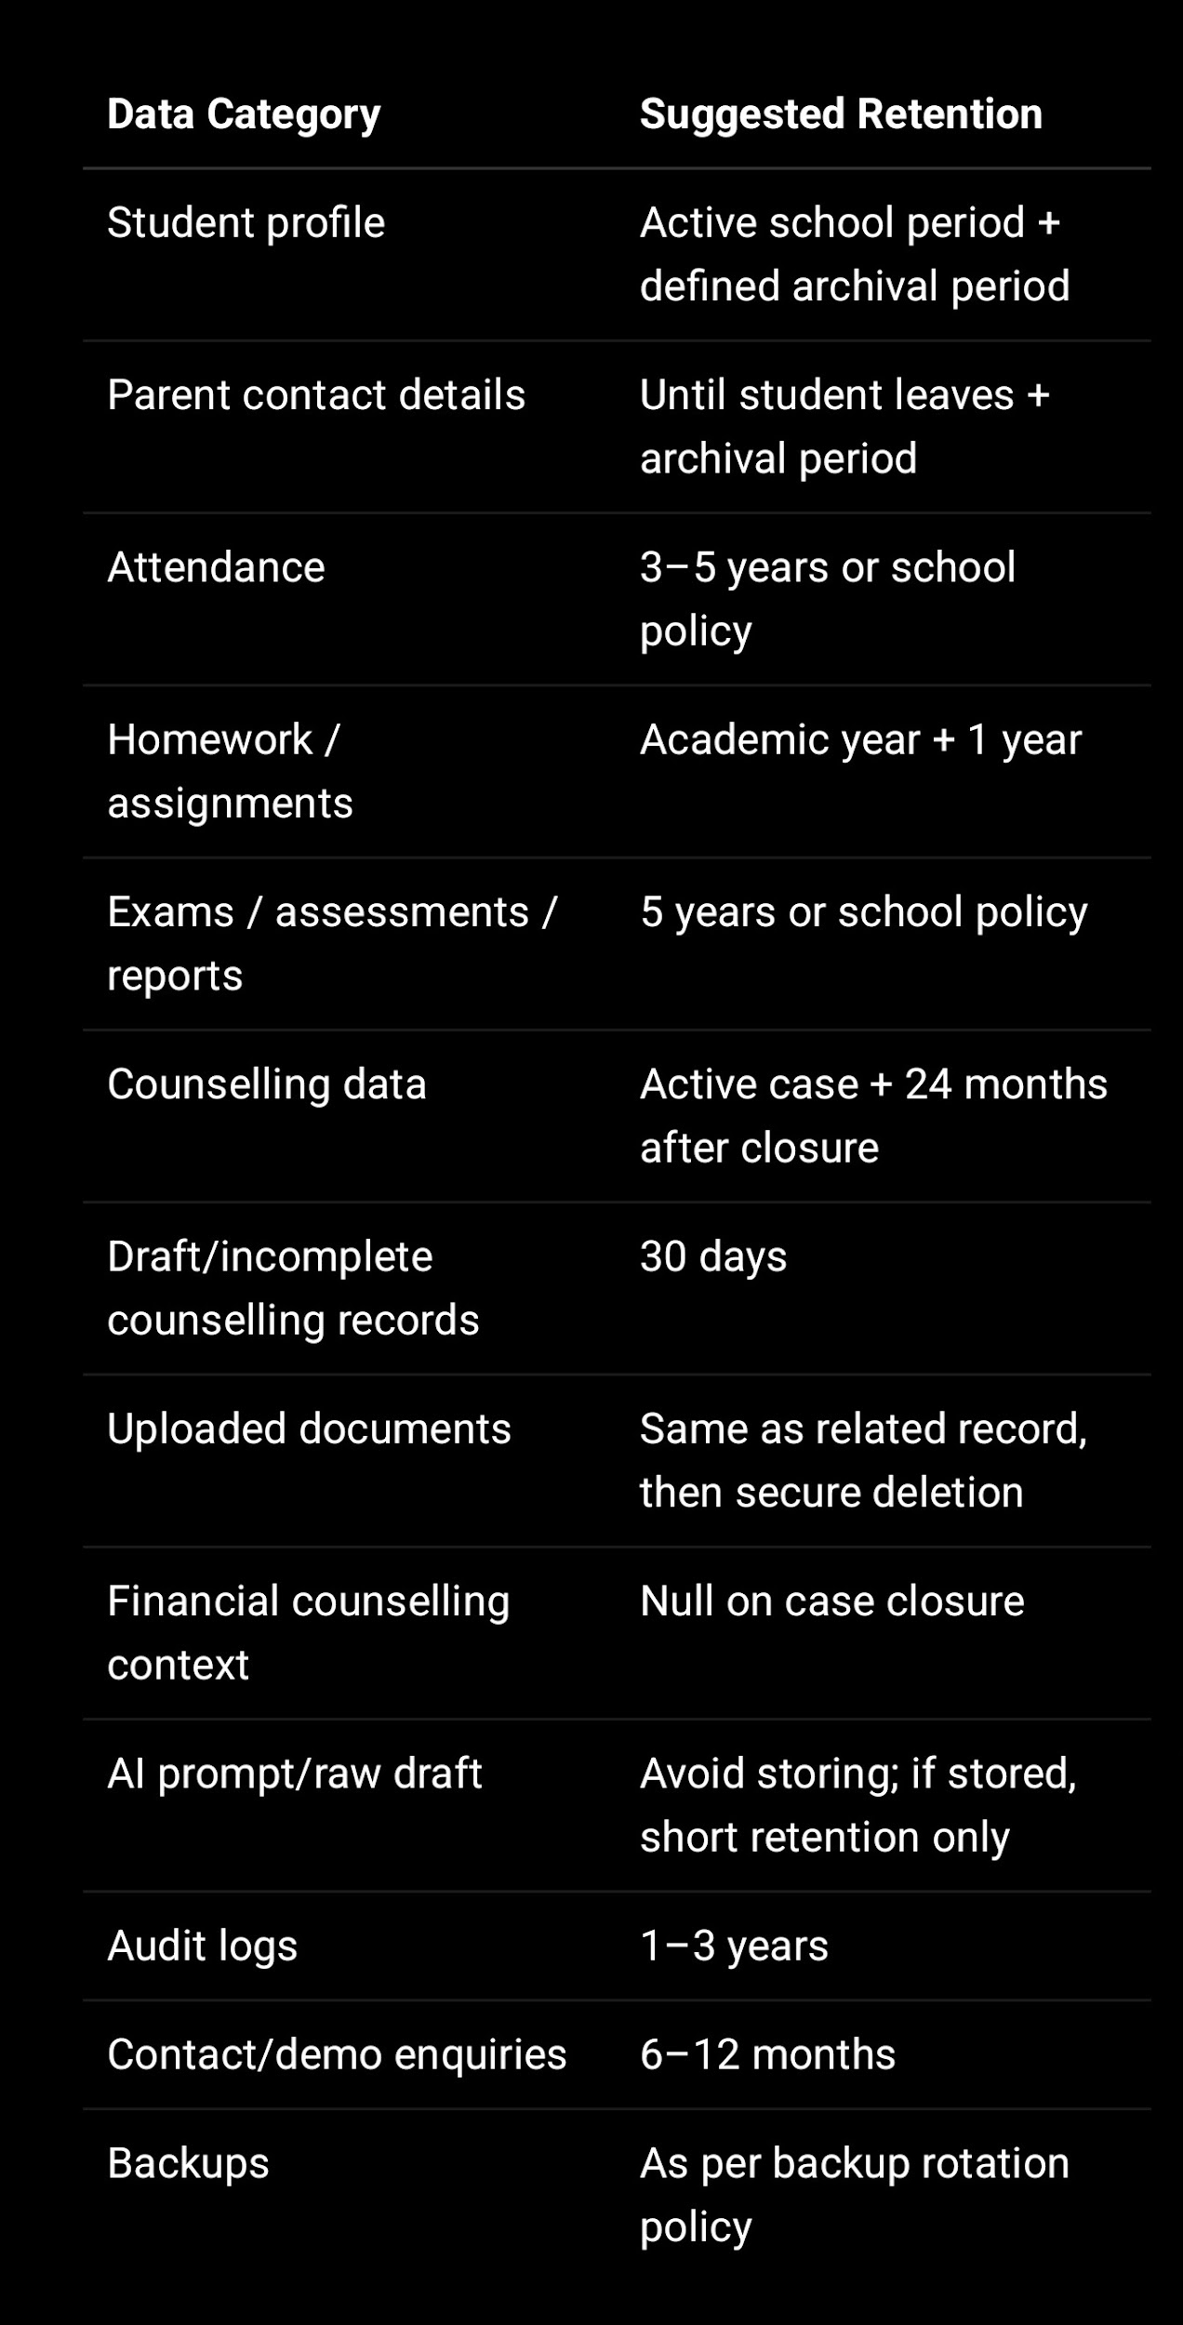
Your form security guide recommends active counselling plus 24 months after case closure, draft/incomplete records auto-delete after 30 days, uploaded documents deleted with records, financial data nulled on case closure, and deletion within 72 hours of valid erasure request.

—

14. Parent / Guardian Rights

Parents/guardians may request:

Access to their child’s data
Correction of inaccurate data
Update of incomplete data
Withdrawal of consent
Deletion/erasure request where applicable
Copy of consent record
Clarification of AI-assisted report
Correction of AI-assisted report
Grievance support

Requests can be submitted to:

privacy@sproutsong.com
support@sproutsong.com

Before acting on a child data request, SproutSong / school may verify the requester’s identity and relationship with the child.

Some records may be retained where required for academic, legal, security, school, audit, or compliance reasons.

—

15. Child-Friendly Safety Principles

SproutSong / SproutMentors should ensure that children are treated respectfully and safely.

The platform should:

Use supportive language
Avoid harmful labels
Avoid unnecessary comparison
Avoid permanent categorisation
Avoid negative profiling
Avoid public exposure of student identity
Avoid targeted advertising
Avoid excessive data collection
Allow correction of inaccurate records
Provide reviewed and understandable reports
Protect student wellbeing

AI, analytics, and counselling outputs must be framed as guidance, not final judgment.

—

16. Breach and Incident Handling for Children’s Data

If children’s data is exposed, accessed by the wrong user, leaked, downloaded without permission, or made public accidentally, SproutSong / SproutMentors should treat it as a serious incident.

Examples:

Student data visible to another student
Parent accessing another child’s report
Teacher accessing another school’s student data
Student document publicly accessible
AI report sent to wrong parent
Database leak
Logs containing student PII
Wrong role permission exposing student data

Immediate actions:

Disable affected API or feature
Revoke affected sessions/tokens
Block public file access
Patch access-control issue
Identify affected students/schools
Check whether data was viewed/downloaded
Notify internal compliance/security team
Notify school/parents where required
Record incident and fix root cause
Improve validation, access checks, logging, and SOPs

Your breach guidance requires checking what data was exposed, how many users were affected, whether children were affected, whether data was downloaded, and whether the issue was internal or external.

—

17. Children’s Data in Development and Testing

Real children’s data should not be used in development, staging, demo, or training environments unless properly authorised and protected.

Development environments should use:

Masked student names
Masked parent phone/email
Dummy marksheets
Dummy reports
Dummy attendance
Dummy counselling records
No real student documents
No real parent contacts
No real AI prompts with student PII

Your DPDP/security report recommends never using real production student/teacher data in development without masking.

—

18. Internal Team Responsibilities

Every SproutSong team member must follow this policy.

Product Team

Collect only necessary child data.
Add consent and purpose text to forms.
Avoid features that create harmful profiling.
Ensure AI outputs are human-reviewed.

Engineering Team

Implement backend access checks.
Apply school-level isolation.
Use encrypted storage.
Prevent direct public file access.
Avoid logging PII.
Add audit logs for sensitive actions.

Counselling Team

Use student data only for counselling purposes.
Avoid harmful language.
Review AI outputs before sharing.
Do not share counselling notes unnecessarily.

School Operations Team

Verify school authorisation.
Confirm parent consent where needed.
Ensure correct role assignment.
Handle parent requests properly.

Compliance Team

Maintain consent templates.
Track policy versions.
Review third-party processors.
Review incidents and data requests.
Conduct periodic audits.

—

19. Required Technical Evidence

For compliance tracking, SproutSong should maintain:

Consent records
Parent/guardian verification logs
Privacy Policy and Terms version
Child Data Protection Policy version
Audit logs for student data access
Report download logs
AI processing logs
File access logs
Data deletion request records
Data retention records
Role/permission change logs
Security incident register
Third-party processor list

Your DPDP/security report recommends audit logs for view, edit, delete, upload, download, export, report generation, and role changes, and it identifies lack of consent/retention fields and lack of audit logs as key risks.

—

20. Website Version — Short User-Facing Summary

Use this summary at the top of the published page:

SproutSong / SproutMentors is committed to protecting children’s data.

We collect student data only for educational, academic, counselling, reporting, communication, and student support purposes. Where required, we obtain parent or lawful guardian consent before processing children’s personal data.

We do not sell children’s data. We do not use children’s data for targeted advertising. We do not allow harmful profiling or negative labelling of students.

Children’s data is protected through role-based access control, school-level isolation, secure storage, private file access, audit logs, and human review of AI-assisted outputs.

Parents/guardians may request access, correction, withdrawal of consent, or deletion by contacting privacy@sproutsong.com.

—

21. Suggested Website Acceptance Text

For student-related forms:

☐ I confirm that I am the parent/lawful guardian or authorised school representative and I agree to the Child Data Protection Policy, Privacy Policy, and Terms & Conditions.

For counselling forms:

☐ I consent to SproutSong / SproutMentors processing the student’s personal, academic, document, and counselling data for educational guidance and counselling purposes only.

For AI reports:

☐ I consent to AI-assisted educational analysis for guidance purposes and understand that AI outputs must be reviewed by a teacher, counsellor, parent, or school authority before final use.

For document upload:

☐ I confirm that I am authorised to upload these student documents and consent to their use only for the stated educational or counselling purpose.

—

22. Internal Compliance Tracking Fields

When published, store this policy in your compliance document collection:

{
documentType: "CHILD_DATA_PROTECTION_POLICY",
version: "v1.0",
title: "SproutSong / SproutMentors Child Data Protection Policy",
status: "PUBLISHED",
effectiveDate: "YYYY-MM-DD",
publishedUrl: "https://www.sproutsong.com/child-data-protection-policy",
approvedBy: "Management / Legal / Compliance",
approvedAt: "YYYY-MM-DDTHH:mm:ssZ",
linkedPrivacyPolicyVersion: "v1.0",
linkedTermsVersion: "v1.0",
changeSummary: "Initial published version",
createdAt: Date,
updatedAt: Date
}

For every child-data consent:

{
userId,
studentId,
parentGuardianId,
schoolId,
documentType: "CHILD_DATA_PROTECTION_POLICY",
documentVersion: "v1.0",
consentType: "CHILD_DATA_PROCESSING",
agreed: true,
checkboxChecked: true,
agreedAt: Date,
relationshipToStudent: "FATHER | MOTHER | GUARDIAN | SCHOOL_AUTHORISED_PERSON",
ipAddress,
userAgent,
requestId,
source: "WEB | MOBILE_APP | ADMIN_PANEL",
consentTextHash,
privacyPolicyVersion: "v1.0",
termsVersion: "v1.0"
}

—

23. Final Publishing Checklist

Before publishing this policy:

- Add official legal entity name.
- Add final support/privacy/security emails.
- Add effective date.
- Add policy version.
- Cross-link Terms & Conditions.
- Cross-link Privacy Policy.
- Cross-link AI Usage Disclaimer.
- Cross-link Data Retention Policy.
- Add consent checkbox to student/counselling/document/AI forms.
- Add parent/guardian verification for minors.
- Add schoolId and consent references in student data records.
- Confirm student files are private and not public.
- Confirm student data access is role-based and school-scoped.
- Confirm logs do not store student PII.
- Confirm AI outputs are reviewed before student/parent visibility.
- Store policy version in consent records.
- Train internal team and school admins on this policy.

—

Final Internal Note

This policy should be published together with:

Terms & Conditions
Privacy Policy
Consent Policy
Data Retention Policy
Breach Response Policy
AI Usage Disclaimer
School Data Processing Agreement
Cookie Policy, if analytics/cookies are used

Your internal readiness guide already lists Child Data Protection Policy as a recommended public document alongside these policies.

